Student’s name | …………………………………………………….…… | Grade | 7
Subject | Computer | Week No. | 5
Lesson Title | Data Transfer | Unit
Worksheet No. ( 5 )
Question A: write the correct name of each part. (P131)

Convert from binary to decimal
110 | 219 | 255 | 136
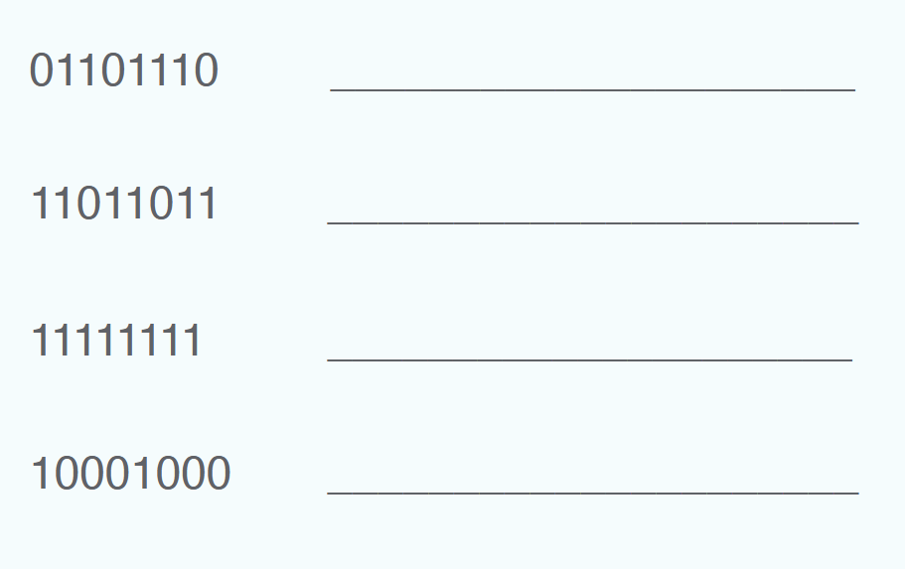
Good Luck

